* A frequently rented filter of 60 days per year as per the high availability metric. A review rate of 50% for the number of guests making a booking who leaves a review. An average booking of 3 nights unless a higher minimum night is configured for a listing.
* "There are about a zillion reasons to visit Austin," the researcher wrote in their study. "Visitors come for music, media, and film festival South by Southwest, a Texas Longhorns football game, or paddle boarding down the Colorado River. And they're all looking for places to crash." - <https://patch.com/texas/eastaustin/austin-9th-best-nation-airbnb-operators-report>
* Each year, Austin plays host to a large number of events such as ACL Festival and SXSW. I’d expect that properties near downtown would garner higher asking prices based on the convenience of location to some of these events.
* 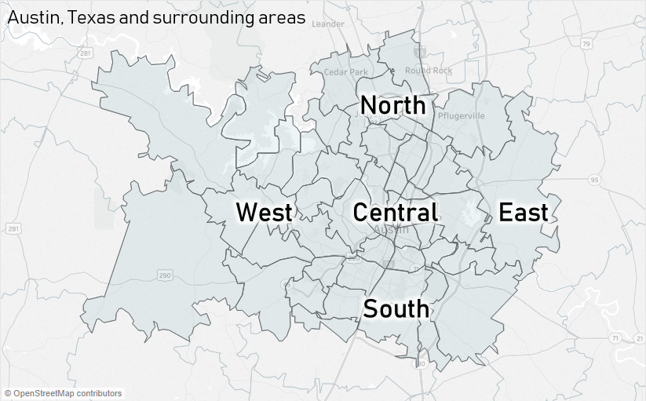
* When compared by region, west Austin trends a bit higher than central in terms of median rental pricing. At first, I was a little surprised by the results, but I think there are likely reasons for this. West Austin is known for its sweeping views of the hill country, affluent communities, and an ideal location that is sandwiched between the popular Lake Travis area and downtown.
* there is a positive correlation between the median rental price versus the rental property size features.
* 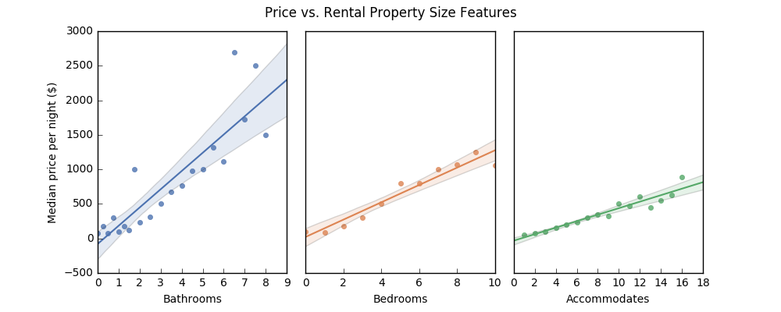
* Of the locations, central Austin was the most important in determining the rental price even though west Austin has the highest median price.
* 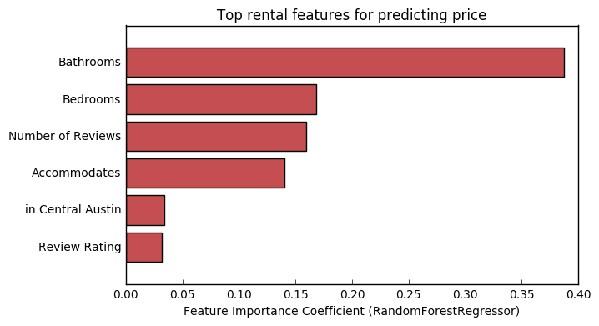
* Recommendation - Do you own a 3 bedroom/2 bedroom home in south Austin? Based on the model, $275 per night would be a good starting point. How about a 1 bedroom/1 bathroom in central Austin? Try $125 per night. Did you invest a lot of resources into renovations and marketing? Maybe add some more to the price.
* Based on the Austin, TX rental data property size matters the most for rental pricing, followed by review ratings and location. Price prediction with reasonable accuracy is possible using standard regression techniques, but subjective aesthetics such as interior design and marketing quality make it challenging to predict rental prices with high accuracy.
* A GitHub repository to go through for analyzing Austin Airbnb data- <https://github.com/daniel-codes/airbnb-austin-tx>